**WEB AND MULTIMEDIA DEVELOPMENT**

**PROJECT**

**NAME: KUDZAISHE PHIRI**

**DUE DATE: 17/05/2024**

**Lecturer: Mr. Simon Chirambira**

Table of contents

Website Specifications.............................................................................3

Information Design & Taxonomy............................................................5

Page Template Design..............................................................................8

Technical Brief.........................................................................................10

Quality Assurance....................................................................................12

Publishing & Promotion...........................................................................18

Future Developments/Recommendations.................................................20

**Website Specifications**

The objective of the task (Warnerbros) website is to provide users with an extensive and enjoyable platform that allows them to access a wide range of entertainment content, including games, apps, movies, and TV shows. The main goal is to increase user retention and engagement through the delivery of excellent information and interactive elements, such as social network integration, forums, and reviews. The company hopes to attract more customers by building its user base and boosting advertising revenue through the website(redesign).

Goals:  
To attract a significant number of people who enjoy entertainment.  
Make reviews and recommendations about films, TV series, documentaries, video games, and other entertainment accessible to the public.

This website caters to a diverse group of entertainment fans. Age is not a problem, as the audience includes teenagers, young adults, and even elderly generations who like entertainment. This website contains something for everyone, whether they enjoy movies, TV shows, video games, or simply keeping up with entertainment and reviews. The target audience is at ease exploring the online world. They're used to surfing websites, streaming content, and interacting with online services. This technologically sophisticated population connects to the internet via a variety of devices, including smartphones, tablets, and desktop computers.

**Information Design & Taxonomy**

The website has a hierarchy information architecture organized by entertainment kind and user behavior. This layout enables users to quickly find the information they require based on their interests and desired actions. This section describes the information architecture and navigation structure of your entertainment website. This includes organizing data, establishing navigation paths, and developing a **sitemap** and **storyboard flowchart**.

Site Map:

* Home
  + - Top picks
    - New releases
    - Upcoming
    - Login
    - Sign up
    - Search
* Movies
* Genres e.g. comedy
* Upcoming
* Trailers
* Reviews
* About movies
* Games and Apps
* Latest Games
* Popular Apps
* News Apps
* Tv Shows
* Latest episodes
* Documentaries
* Reality Tv
* Sitcoms
* Collection
* Bingeworthy
* Black voices
* Friends
* Romance
* DC
* Feedback
* Customer Information
* Feedback type

Storyboard flowchart :

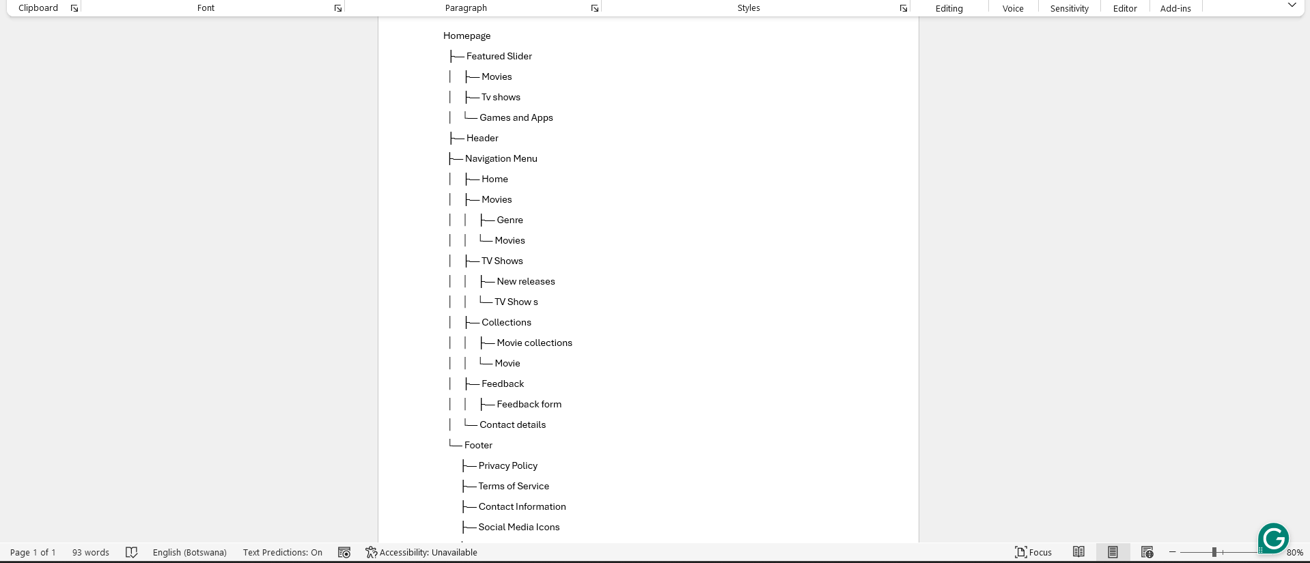

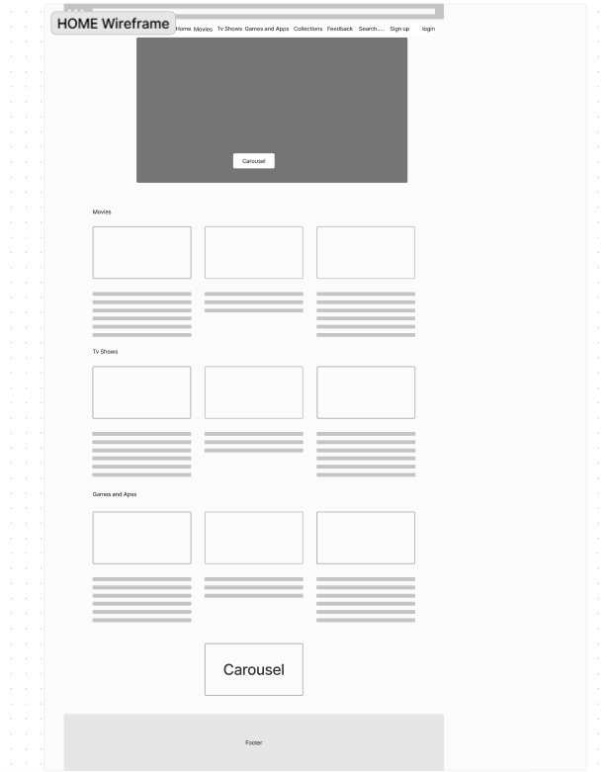**Page Template Design**

An entertainment website's design should be visually appealing, user-friendly, and easy to navigate. The template should support a variety of content kinds, including reviews, and user interactions. The page template design is described in detail above, along with wireframes to show how it will look when completed.

**Technical Brief**

The technology and techniques used to create the entertainment website are described in this part, considering the requirement to strike a balance between functionality and complexity. A combination of front-end and back-end technology, along with several tools for quality control, content management, and graphics, are needed to develop an entertainment website. A thorough technical brief describing the essential tools and technologies I used are provided below:

HTML5: Offers the website's main content and structure.  
The ability to style a website's visual elements (colours, fonts, and layout) for a responsive and eye-catching design is made possible by CSS3.  
JavaScript: Provides interactive components e.g., carousels and dynamic content loading to improve user experience and interactivity.  
Goal: To make sure that mobile devices are prioritized in design. Using Bootstrap.

Note that

Using HTML5, CSS3, JavaScript, and the Bootstrap framework, this project attempts to create a modern, visually appealing, interactive, and flexible entertainment website. The emphasis on clear documentation and best practices guarantees a well-structured, manageable, and secure website in the long term.

**Quality Assurance**

Quality assurance (QA) is a detailed technique for ensuring that an entertainment website satisfies standards and provides a great user experience. It includes some testing approaches and procedures for detecting and addressing issues before the website is launched.

Here are some important features of QA that I used on my website explained in detail:

Functionality Test

Navigation: Ensure that all links and navigation menus lead users to the correct pages.  
Content Management: Ensuring that all content (movies, TV shows, music, and apps) are properly presented and accessible.  
Search Functionality: Test the search box to ensure that it displays relevant results based on keywords for movies, TV shows, games, and so on.  
User Interactions: Ensure that features such as user reviews, ratings, and forums work properly.  
Forms: Checking feedback forms, sign-up forms, and other interactive features to ensure that data is entered and processed properly.

Performance Testing

Examine the differences in page load times between slow, moderate, and high internet connection speeds. Long wait times can result in discontent and abandonment; this avoids that.  
Examine how well a website performs while it is loaded, simulating multiple users at once. This guarantees that, during times of high traffic (like movie premieres and the introduction of new seasons), the website will remain responsive and reliable.

Usability Testing

Usability testing determines how easy and user-friendly a website is to use this includes:

Determining how easy it is for users to browse the website and locate the information they require. Test the navigation menus, search functionality, information architecture, and overall layout.  
Evaluate the user interface (UI) for clarity and usability. This includes evaluating button placement, labelling, font sizes, and responsiveness on various screen sizes (desktop, mobile, and tablets). Conduct user testing sessions to see how actual users interact with the website and identify any points of uncertainty.  
Design Consistency: Ensure a uniform design across all pages to provide a cohesive user experience.  
Accessibility: Ensuring that the website is accessible to people with impairments, including screen reader compatibility and keyboard navigation.

Compatibility Testing

Use a variety of web browsers to make sure the website functions properly on desktop and mobile devices (Chrome, Firefox, Safari, and Edge). This entails evaluating functionality, responsiveness, and layout on various platforms. It's important to maintain consistency because different browsers may render components differently.  
  
Test compatibility with several operating systems (Windows, macOS, Android, and iOS) to provide a consistent user experience. Users should be able to use and enjoy the website regardless of device or operating system.

Additional points

Recognizing potential conflicts:  
Manual Evaluation: This is a crucial first step, even though it takes time, to test your website manually across various browsers and technological scenarios. Check for modifications to the design, functionality, and style.  
Browser developer tools: Developer tools are built into every browser and let you examine a website's code to find possible issues. Check for JavaScript errors, rendering inconsistencies, and compatibility problems with these tools.  
Online testing tools can automatically evaluate your website and identify any issues with cross-browser compatibility. Although these techniques can save a great deal of time, comprehensive coverage always requires manual testing.

A web development technique called responsive web design (RWD) makes sure that the functionality and layout of your entertainment website adjust to various screen sizes and devices (desktops, tablets, and mobiles). In the modern world, when people visit websites from a wide range of devices with different screen sizes and resolutions, this is essential.  
  
Advantages of RWD  
Improved User Experience: RWD makes sure that users, on any device, have a good experience. To ensure readability and user-friendliness, navigation elements, information, and graphics are automatically adjusted.  
Better Search Engine Optimization (SEO): Mobile-friendly websites are favoured by search engines. RWD may increase traffic to your website by ensuring that it is correctly indexed and shown in search results on all platforms.

To improve maintainability and future changes, my code has standard practices for well-commented and documented documentation.

Google Chrome:

**Publishing & Promotion**

My website will be hosted on GitHub Pages, a free service offered by GitHub that allows users to publish websites directly from their Git repositories.

Promotion

These are my preferred techniques to promote this website, and I've explained how they work in detail:

Social Media Marketing: Promote your website on social media networks that your target audience uses (such as Facebook, Twitter, and Instagram). Share compelling content, trailers, reviews, and news to broaden your audience and increase traffic to your website.  
Employ search engine optimization (SEO) best practices to raise the position of your website in search engine results pages (SERPs). Researching keywords, creating content, and acquiring backlinks from other websites may all be necessary for this.  
Material Marketing: Produce high-quality, and entertaining content that is relevant to your target audience's interests. This may include film reviews, listings, and celebrity interviews. Regularly updated content keeps users engaged and encourages them to return for more.

We were tasked to use GitHub to host our websites for this project, but after doing some research, I discovered certain advantages, thus I personally support the utilization of GitHub.

The benefits include:

It is free and Simple to Use: Setting up deployment is as simple as connecting your GitHub repository to GitHub Pages; there are no extra web hosting fees.

Custom Domain Name: For a more polished appearance, you can connect a custom domain name even if GitHub Pages offers a free subdomain.

**Future Developments/Recommendations**

Here are the changes I will be making to the website as I hone my web design skills. There are many more ways I would have loved to take on this project, and I will keep learning and editing it until it reaches its full potential.

To broaden content offerings by including podcasts, interviews with industry specialists, and audio reviews to appeal to people who prefer audio-based entertainment. Also to create a recommendation engine that recommends movies, TV series, music, and games based on user preferences, and viewing history. This personalizes the user experience and keeps them interested by introducing new content.

I am definitely going to consider:

Creating a more engaged and engaging online community by incorporating interactive components such as polls, quizzes, and user-generated content areas (e.g., fan theories, and chats).

To Improve search and navigation which prompts users to discover content quickly and effectively.

I will make sure to apply the best practices for online security to secure user data and prevent security flaws.

In the future, I would like to improve the websites' availability and ways of promotion to the public.

These are:

Due to a recent discovery about how Microsoft Edge does not necessarily support CSS3, I will continue to address compatibility issues with this web browser to improve user experience.

The point below are how I will personally be tackling this problem:

Employing browser prefixes: To guarantee compatibility with more CSS3 features, take into account employing vendor prefixes like -ms- for Edge. It can be a temporary fix, even though it's not the best option for long-term maintainability.

Progressive Enhancement: For browsers that support them fully, employ advanced CSS3 features to gradually improve the user experience while concentrating on the essential functions of your website with basic CSS. With additional functionality for compatible browsers, this guarantees a positive experience for all users.

Due to this problem I have used Library frameworks such as Bootstrap and the implementation of JavaScript into my website